step 1： manual set ip address as below:
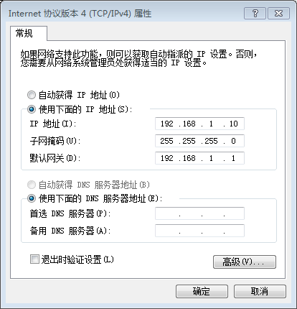
setp2: put Uboot in the TFTP folder

step 3: power on router, after enter the Uboot excute the following 3 command:

tftp 0x80060000 breed-qca953x-letv-lba-047-ch.bin
erase 0x9f000000 +0x20000
cp.b 0x80060000 0x9f000000 0x20000

step 4: after flash the new Uboot , you can use 192.168.1.1 to flash new openwrt firmware

